Student Fitness Data
What is WELNET?
WELNET® is an easy-to-use, web-based software application that was developed as a tool for students to understand their health and fitness and build a personal portfolio. WELNET® consists of seven modules that students may be completing assignments in: fitness, assessments, behavior logs, rubrics, wearables and online learning.
Prince William County Public Schools (PWCS) will be using WELNET® in grades 3-10 in their health and physical education classes beginning in the 2019-2020 school year.
How to Log in:
- Log into Office 365
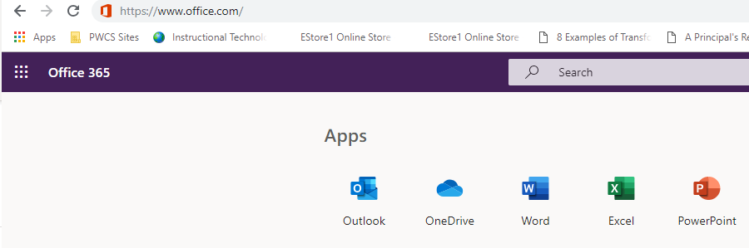
2. Click on the Waffle in the upper left corner of the window.

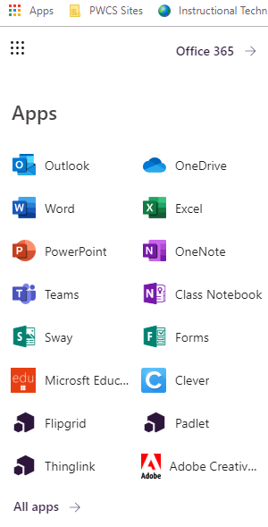
3. Students may see the Clever icon in the list of apps here or they may need to click on the All Apps link.

4. Once Clever opens, you will need to scroll though the apps to find the WELNET® App.
Student Dashboard:
In WELNET® they will see their dashboard with all current assignments.
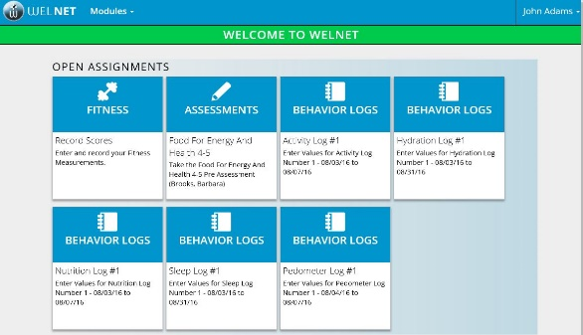

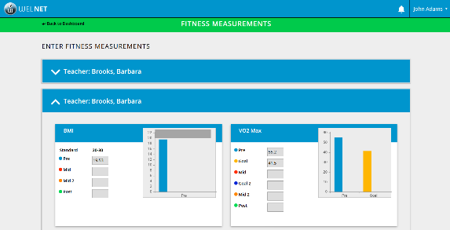
Student Fitness Profile:
Students complete fitness measurements on a yearly basis. They can view their results compared to national standards on the Fitness page and set personal goals and write plans for improvement.
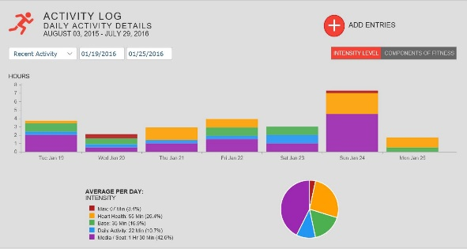
Student Behavior Logs:
Students have the ability to track their behaviors on activity, nutrition, sleep and hydration logs. Students can view their behaviors over time and compare them to recommendations.
Please contact your student’s health and physical education teacher for further information or questions regarding WELNET®. The health and physical education program in the PWCS Office of Student Learning can also be reached at 703.791.7270.
Focused Fitness is a signatory on the Student Privacy Pledge. All data is protected using the latest security measures. For more information regarding Focused Fitness’s Data Privacy Policy, go to: https://www.focusedfitness.org/privacy-policy.

