**SeaPerch Logo**

****Northern Virginia’s Regional SeaPerch Challenge****

****International Space Station****

The Mission Course consists of four tasks across the task frame. Tasks may be completed in any order with the exceptions noted in individual tasks.

The time limit is 6 minutes for this challenge. Teams may compete their runs two times within the given rotation period.

**Mission Course Navigation & Rules:**

1. Start of run: The ROV must be surfaced, within six inches (6”) of the wall, and under its own power. Team members are not allowed to touch the ROV after the lane judge begins the countdown to start the run.
2. Batteries may be transported in any order.
3. Multiple objects may be transported at the same time.
   1. Once a used battery has been removed from the battery compartment (Task 3), points will not be awarded for opening the battery panel (Task 1).
   2. Points will not be awarded for disconnecting power cables (Task 2) if the disconnection occurs due to used batteries being moved.
   3. Points will not be awarded for multiple tools left on a single hook in the tool caddy (Task 4).
4. End of Run: The timer will be stopped when the ROV touches the pool wall while surfaced (any part of the ROV breaks the surface of the water). Teams will receive points for all tasks completed during the run and bonus points will be awarded to teams to complete their run prior to the maximum allotted time.

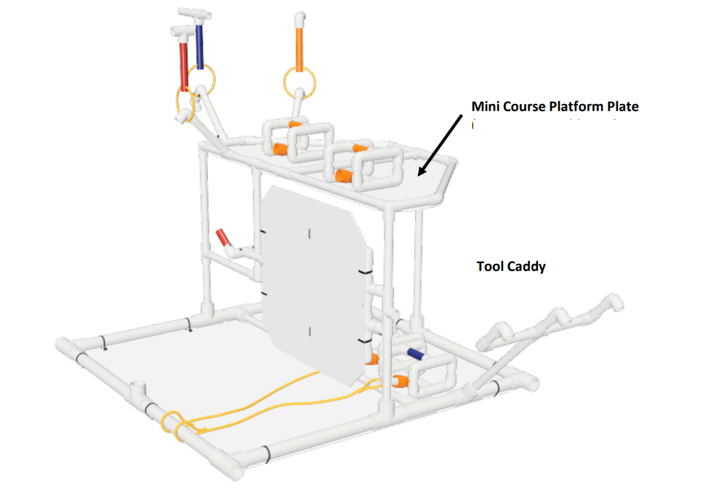

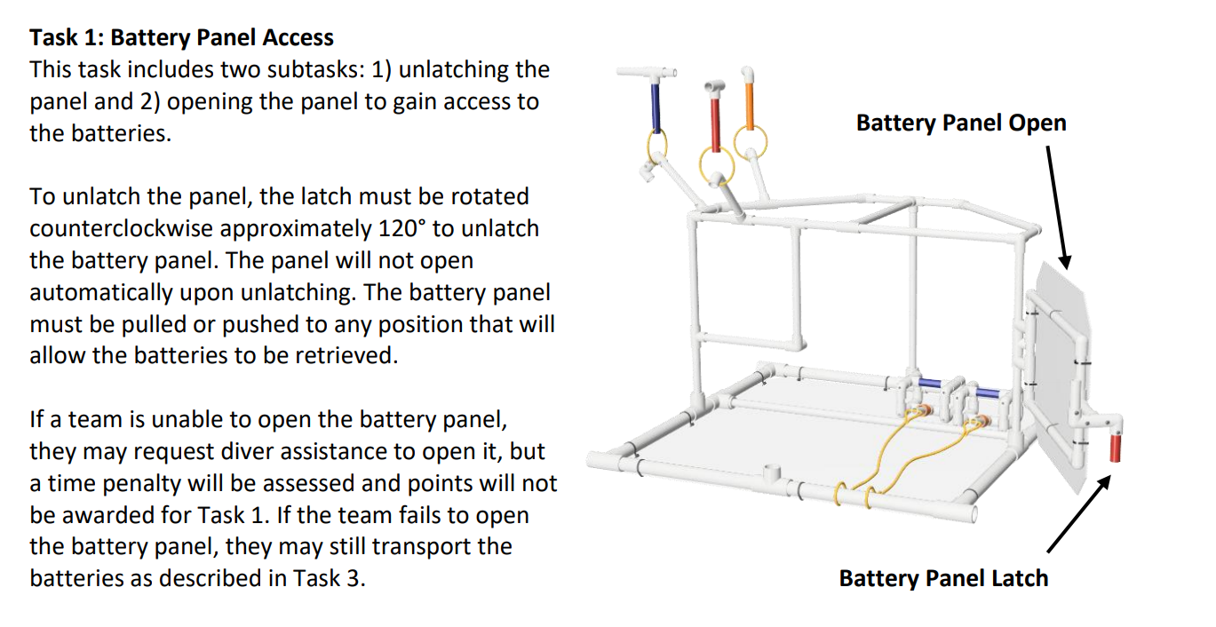

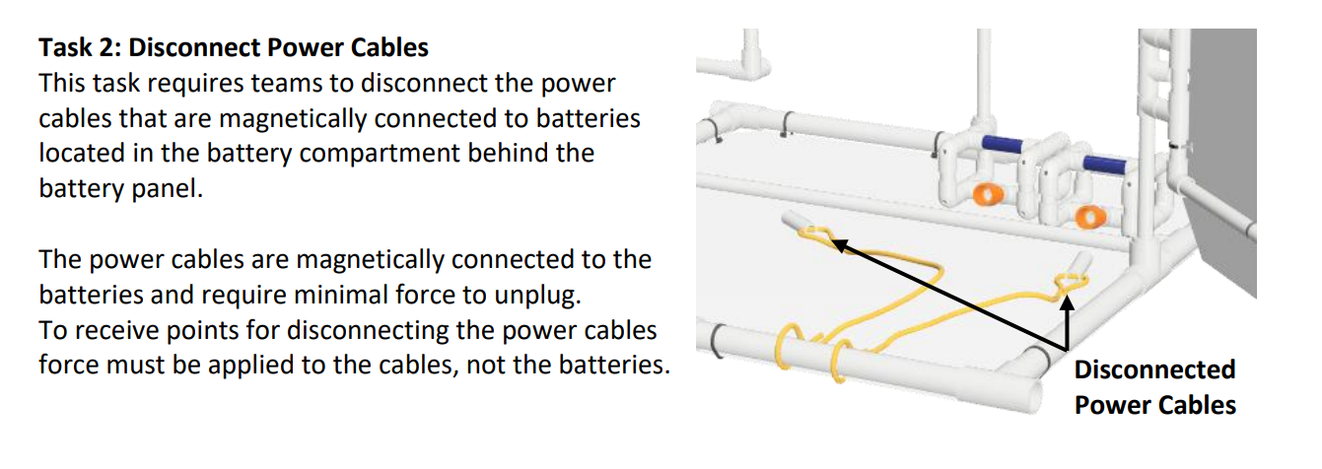

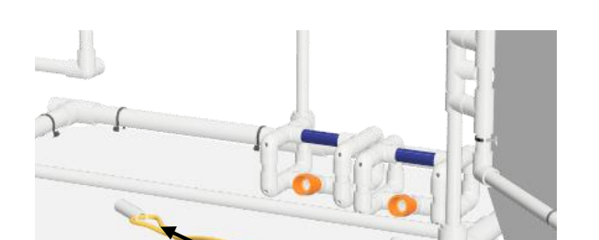**Task 3: Replace Batteries**

Now that the door is open and the power cables are removed,

ROVs will replace the old batteries (blue) from low battery compartment to high battery pallet.

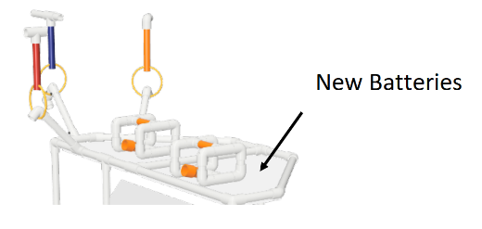New batteries (orange) will be moved from battery pallet to the battery compartment.

**Task 4: Tools**

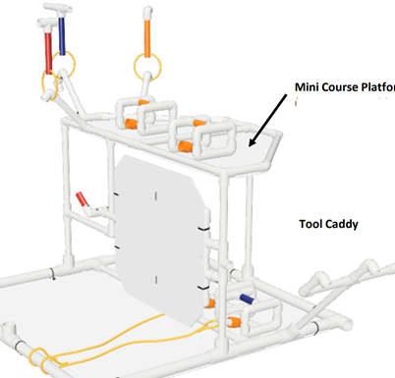Now it is time to clean up. This task requires teams to move three (3) tools from the EVA tool tray on the front task frame to the Tool Caddy on the bottom task frame.

The tools are slightly positively buoyant and may float away during transport. Tools may be transported in any order and may be placed on any open hook on the tool caddy. Only one tool may be placed on each hook.