SeaPerch Logo

****Northern Virginia’s Regional SeaPerch Challenge****

****Obstacle Course Challenge****

The team with the most points will win the Obstacle Course Challenge. If teams have the same number of points, the team with the fastest time wins. The time limit is 5 minutes for this challenge. Teams may compete multiple times as allowed within the given rotation period.

Background:

An underwater remotely operated vehicle (ROV) must be able to maneuver successfully under its own power. If an ROV cannot maneuver to the appropriate location to perform its task, the ROV is of no use.

The submerged obstacle course involves large rings (18" minimum diameter), oriented in any direction, through which the ROVs must travel. Teams must navigate through the obstacle course, surface, then re-submerge and return through the course to the end.

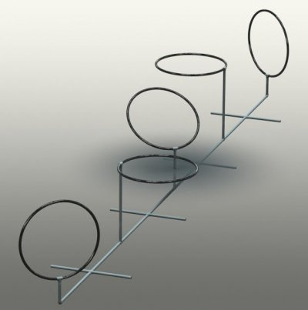

****Strategy Examples:****

Consideration of optimal maneuverability, control and speed should be given when constructing your SeaPerch (thruster placement and orientation, tether attachment, buoyancy and ballast, etc.) and control box. Scores for this round will be based on the total points and the time used to navigate the obstacle course.

****Game Structure:****

There are five (5) -18" diameter hoops in the obstacle course.

* Teams are required to travel through each of five 18” rings, surface, and return back through the five rings.
* ROVs shall begin travel through the rings in order, starting with the closest to the wall first.
* Highest number of points with fastest elapsed time of a successful course wins.
* If teams do not complete the course within the five-minute time limit, ROVs will be removed from the water.
* If time allows in the rotation period, teams will be given additional attempts to complete the Obstacle Course. Their best time will be used.
* In the event of a tie (i.e. teams have the same number of points and the exact same time), the team with the most points in an additional run, will be the winner.

**Keep in Mind:**

1. Each ROV must be touching the wall of the pool prior to start.
2. The score sheet will be marked for each ring traversed, ROV surfacing, and rings traversed back to wall.
3. Time is stopped when the SeaPerch successfully returns and touches the wall. The SeaPerch does not need to be on the surface at the finish.
4. The team with the highest points and fastest time for a successfully completed course will win the Obstacle Course Challenge.
5. The Obstacle Course Challenge has a time limit of 5 minutes per team per attempt. If time allows in the rotation period, teams will be given additional attempts to complete the Obstacle Course. A tie is broken by the scores for any additional team run.

**Game Rules:**

* The ROV MUST touch the wall at the start of the game; an operator should hold the ROV in place until the start signal is sounded. (penalty item – false start)
* The ROV Control Box must be on the ground at the start of each game; when the start signal is sound, an operator may pick up the controls. (penalty item – false start)
* The tether may NOT be pulled on during the game. (penalty item – pulling on tether)
  + A team member may “manage” the amount of tether cable in the water, feeding and retracting length as desired, but the tether cable must be slack at all times; the team member may not use the tether cable to assist the ROV’s movement in any way.
  + Subject to the lane referee’s discretion.
* Teams may NOT exceed the five-minute time limit. The ROV will be removed from the course.

****Provision for False Start, False Finish, and Tether Pull:****

* If a team has a “false start” defined as the ROV left the wall before the start signal, 5 points will be subtracted from that team’s score.
* If a team has a “false start” defined as an operator has the controller in possession prior to the start signal; 5 points will be subtracted from that team’s score.
* If a team has pulled on the tether cable to change the ROV’s movement; 5 points will be subtracted from that team’s score.