**seaperch logo**

****Northern Virginia’s Regional SeaPerch Challenge****

****The Speed Challenge****

The team with the lowest time in this challenge will win this challenge. Time Limit is **3 minutes** for this challenge. Teams may compete multiple times as allowed within the given rotation period.

****Structure of the Game:****

[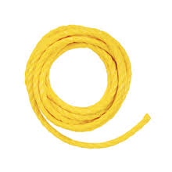](http://www.google.com/imgres?imgurl=http://guide.alibaba.com/sport/images/shop/69/08/07/8/lehigh-1-4-in-x-100-ft-yellow-braided-polypropylene-rope_2068898.jpeg&imgrefurl=http://guide.alibaba.com/shopping-guides/1-polypropylene-rope.html&h=276&w=276&tbnid=INv01I27T4gXPM:&zoom=1&docid=-CTFZt8hxlAlMM&ei=L4GZVK6lOsOvyAS3sYGoAw&tbm=isch&ved=0CCgQMyggMCA4ZA&iact=rc&uact=3&dur=182&page=3&start=94&ndsp=46)As underwater ROV technologies advance, their applications will be numerous. Some tasks require the ROV to be precise with its movability. Other tasks may require the ROV to transport itself or items from a certain location to another as quickly possible. So this challenge is all about speed. The Speed Challenge will require the ROV to move from point A to point B in the least amount of time.

The Speed Challenge will require two teams – if possible. Each team will utilize a driver and tether cable manager. Both teams will start in the center of the pool and direct their ROV towards the pool wall. There will be a starting line of floating rope which teams will place their ROVs behind.

Tether cable managers and drivers must be especially careful not to get the two ROVs’ tether cables tangled on each other.

The judge will start the challenge and the ROVs will race to the wall as fast as they can. Be careful not to use the tether to pull the ROV to the edge.

****Strategy Examples:****

Consideration towards optimal propulsion speed and finely-tuned depth control should be given when constructing the SeaPerch ROV for the Collaboration Challenge; motor placement and orientation, tether attachment, buoyancy and ballast, and your control box, can all have an effect on the ROV’s performance.

****Scoring:****

The Speed Challenge will be a timed challenge. Poolside judges will only put the lowest time a team takes to complete the challenge; the score keeper will enter the lowest time achieved by each team.

****Game Rules:****

[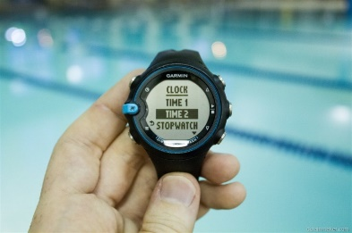](http://www.google.com/url?sa=i&rct=j&q=&esrc=s&frm=1&source=images&cd=&cad=rja&uact=8&ved=0CAcQjRw&url=http://www.dcrainmaker.com/2012/06/garmin-swim-watch-in-depth-review.html&ei=goWZVPfUCMGcyASTu4CgAw&bvm=bv.82001339,d.aWw&psig=AFQjCNHv-dPt0-eB_mLiIhcDMEp_8wSuGQ&ust=1419433696220522)

* The Speed Challenge will have a time limit of **3 minutes**. Judges will use stop watches to determine the time length. Judges will signal when the 3 minutes are up. At this time, all operators must place the ROV objects they are holding on the ground.
* The ROV is placed behind the starting line in the center of the pool. The starting line is a floatable rope that is placed approximately 12.5 meters from center of the pool and race to the edge of the pool. The fastest time will be calculated and turned into the score keeper.
* **ROVs should remain submerged during this race. Teams that have an ROV that travels along the entire surface of the water or teams that do not remain submerged will be disqualified.** (penalty item – not remaining submerged)
* An operator should hold the ROV in place until the start signal is sounded. (penalty item – false start)
* The ROV control box must be on the ground at the start of each game; when the start signal is sound, an operator may pick up the controls. (penalty item – false start)
* The tether may NOT be pulled on during the game. (penalty item – pulling on tether)
  + A team member may “manage” the amount of tether cable in the water, feeding and retracting length as desired, but the tether cable must be slack at all times; the team member may not use the tether cable to assist the ROV’s movement in any way.
  + Subject to the lane judge’s discretion.
* The ROV will touch the wall before the judge can stop the timer. Teams should not remove the ROV until given permission from the judge.

****Provision for Penalties:****

* If a team’s ROV has left the start rope before the start signal OR an operator has the controller in possession prior to the start signal OR the team pulls on the tether OR the ROV does not stay submerged; time will not be calculated for that team and they will be marked as Disqualified.