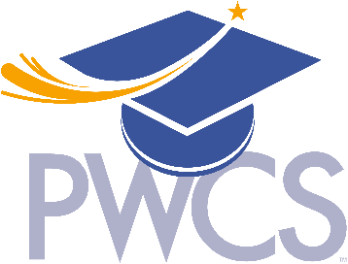
Visual Art

PWCS Local Audition

Audition Content

Applicants will present a portfolio containing ten pieces of original artwork from the

following media:

Drawing, Painting, Mixed Media, Printmaking, Photography, Ceramics, Sculpture, Installation, Collage, Assemblage, Video, and New Media.

Each piece should fall into one of the following categories:

Core Portfolio: Six artworks should share a standard media, working method, or theme.

Supplementary: Four artworks should differ from the Core Portfolio to show variety, experimentation, and growth.

The Portfolio should be submitted as a PDF.

Judging Criteria

Design (cohesiveness of composition)

Expression (communicative quality)

Originality (novel or unique solutions)

Fluency (number of ideas and concepts)

Flexibility (variety of work and ideas)

Elaboration (stretching or expanding imagery)

Artist’s Statement
150-200 word artists statement addressing your core and supplementary choices (how each piece fits the category) and how you can grow as an artist by attending SRGS.

