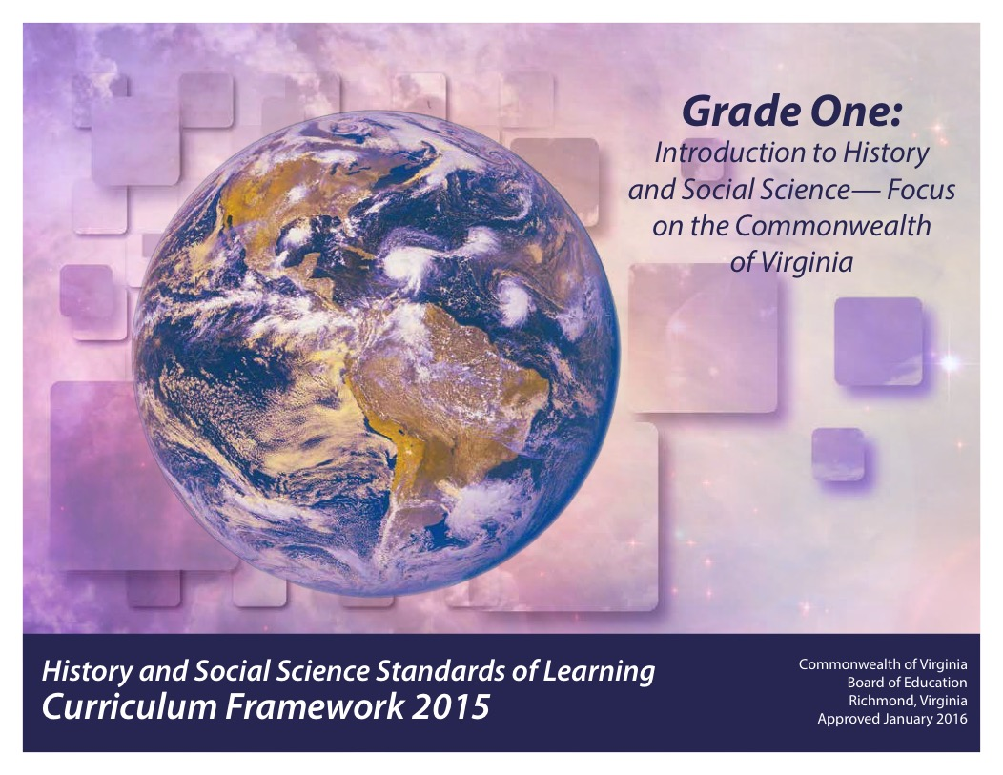
Updated: December 2020

Copyright © 2016
by the
Virginia Department of Education
P. O. Box 2120
Richmond, Virginia 23218-2120

All rights reserved. Reproduction of these materials for instructional purposes in public school classrooms in Virginia is permitted.

Superintendent of Public Instruction
Steven R. Staples

Chief Academic Officer/Assistant Superintendent for Instruction
John W. “Billy” Haun

Office of Humanities and Early Childhood
Christine A. Harris, Director
Christonya B. Brown, History and Social Science Coordinator
Betsy S. Barton, History and Social Science Specialist

NOTICE
The Virginia Department of Education does not unlawfully discriminate on the basis of race, color, sex, national origin, age, or disability in employment or in its educational programs or services.

INTRODUCTION
The History and Social Science Standards of Learning Curriculum Framework 2015, approved by the Board of Education on January 28, 2016, is a companion document to the 2015 History and Social Science Standards of Learning for Virginia Public Schools. The Curriculum Framework amplifies the Standards of Learning by defining the content understandings, knowledge, and skills that are measured by the Standards of Learning assessments.
The standards and Curriculum Framework are not intended to encompass the entire curriculum for a given grade level or course, nor to prescribe how the content should be taught. School divisions are encouraged to incorporate the standards and Curriculum Framework into a broader, locally designed curriculum. The Curriculum Framework delineates in greater specificity the minimum content that all teachers should teach and all students should learn. Teachers are encouraged to go beyond the standards and select instructional strategies and assessment methods appropriate for their students. Additional details such as the names of historical figures whose study further enriches the standards and clarifies the concepts under investigation will be found in the Curriculum Framework.
The Curriculum Framework facilitates teacher planning by identifying essential understandings, knowledge, and skills. Together, these key elements provide the focus of instruction for each standard. The purpose of each section is explained below:

Standard of Learning Statement
Each page begins with a Standard of Learning statement as a focus for teaching and learning. Students will apply social science skills to understand the interrelationships between the history, geography, economics, and civics content, as well as become actively engaged in their learning.

Essential Skills (Standard 1)
The essential history and social science skills are outlined in Standard 1 for each grade level or course. Students use these skills to increase understanding of the history and social sciences content, including historical, geographic, political, and economic events or trends. The development of these skills is important in order for students to become better-informed citizens.
The first column for Standard 1 contains “Essential Understandings,” which are described below. The second column contains examples of how the skill may be applied in the classroom.

Note: The skills will not be assessed in isolation; rather, they will be assessed as part of the content in the History and Social Science Standards of Learning.

Essential Understandings
This column includes the fundamental background information necessary to acquire and apply the essential knowledge. The understandings should help students develop a sense of context, including why the essential knowledge is relevant to the standard; thus, teachers should use these understandings as a basis for lesson planning.

Essential Knowledge
This column delineates the key content facts, concepts, and ideas that students should grasp in order to demonstrate understanding of the standard. This information is not meant to be exhaustive or a limitation on what is taught in the classroom. Rather, it is meant to be the principal knowledge defining the standard.

The Curriculum Framework serves as a guide for Standards of Learning assessment development; however, assessment items may not and should not be verbatim reflections of the information presented in the Curriculum Framework.

STANDARD 1.1a
The student will demonstrate skills for historical thinking, geographical analysis, economic decision making, and responsible citizenship by
a) using artifacts and primary and secondary sources to develop an understanding of Virginia history;

Essential Understandings
Using artifacts and primary and secondary sources includes making observations and connections, asking questions, and reflecting.
An artifact is an object or tool that reveals something about the past.
A primary source is an artifact, document, image, or other source of information that was created during the time under study.
A secondary source is a document, image, or other source of information that relates or discusses information originally presented elsewhere.
Experiences may include but are not limited to the following:
- View a picture of an early settlement and ask questions about why the people created the type of shelter depicted.
- Use an image and a description of a historic home in Virginia to ask questions and make observations about how daily life when the home was built is different from daily life today.
- View a map of 1607 Virginia and a map of Virginia today and ask questions about how the maps compare.
- View an image of a job from Virginia’s past and compare it to a job in Virginia today.

STANDARD 1.1b
The student will demonstrate skills for historical thinking, geographical analysis, economic decision making, and responsible citizenship by
b) using basic map skills to support an understanding of Virginia history;

Essential Understandings
Maps help develop an awareness of where places are located in Virginia.
Maps use directionality and symbols to identify or indicate a location.
Geographic information obtained from maps supports an understanding of Virginia history.
Using simple maps develops an awareness of how places in Virginia have changed from the past to the present.

Experiences may include but are not limited to the following:
Viewing maps of Virginia
- Make simple observations about what the symbols on a map represent.
- Identify landforms, such as mountains, on a map.
- Identify the Atlantic Ocean on a map.
- Identify water features on a map.
- Illustrate why people settled near the rivers in Virginia.
- Use cardinal directions to describe how people traveled from one place to another.

Constructing maps
- Create a simple drawing of the classroom, school, community.
- Create and/or label a simple map of Virginia to show
- where selected Virginians lived.
- the locations of Washington, D.C., and Richmond.

STANDARD 1.1c
The student will demonstrate skills for historical thinking, geographical analysis, economic decision making, and responsible citizenship by
c) using and creating graphs, diagrams, and pictures to determine characteristics of people, places, or events to support an understanding of Virginia history;

Essential Understandings
Graphs, diagrams, and pictures help students develop an understanding of people, places, and events in Virginia history.

Experiences may include but are not limited to the following:
- Use a Venn diagram to organize information about goods and services in Virginia.
- Create symbols to represent the contributions of selected individuals in the history of Virginia and organize the symbols in a chart.
- Use a simple bar graph of seasonal temperatures to determine how the time of year affects the ways that people in Virginia meet their basic wants.
- Create a chart of Virginia symbols that includes the Virginia flag, the state capitol building, the state bird, and the state flower. Conduct a survey to determine which symbol students find most meaningful. Graph the results of the survey.
- Create a graphic organizer of jobs in Virginia from the past and the present.

STANDARD 1.1d
The student will demonstrate skills for historical thinking, geographical analysis, economic decision making, and responsible citizenship by
d) asking appropriate questions to solve a problem;

Essential Understandings
Asking a variety of questions extends learning and deepens understanding.
Asking questions involves making observations about the world and framing them as inquiries to solve a problem.

Experiences may include but are not limited to the following:
- Ask a variety of questions before and after reading about an influential person or event in the history of Virginia.
- Create a simple drawing of the classroom, school, community.
- Use images of different locations in Virginia to generate questions.
- Ask questions about goods and services to determine what to choose and what to give up.

STANDARD 1.1e
The student will demonstrate skills for historical thinking, geographical analysis, economic decision making, and responsible citizenship by
e) comparing and contrasting people, places, or events in Virginia history;

Essential Understandings
Comparing and contrasting examines similarities and differences among people, places, or events.
Communities in Virginia have different physical and cultural characteristics.

Experiences may include but are not limited to the following:
- Create a class Venn diagram to compare the lives of famous Virginians.
- View maps and images of different locations in Virginia to compare which recreational activities are popular across the state.
- Create a Venn diagram to compare how different holidays are celebrated.
- Create a class chart of how selected jobs have changed over time.

STANDARD 1.1f
The student will demonstrate skills for historical thinking, geographical analysis, economic decision making, and responsible citizenship by
f) recognizing direct cause-and-effect relationships;

Essential Understandings
A cause-and-effect relationship is a relationship in which one event (the cause) makes another event (the effect) happen.
Identifying cause-and-effect relationships helps us understand specific events in Virginia history.
Cause-and-effect relationships can be observed in school, in the community, and in state history.

Experiences may include but are not limited to the following:
- Use information about the location, climate, and physical surroundings of Virginia to discuss how each of these affects the way people meet basic wants, such as the foods they eat, the clothing they wear, and the kinds of houses they build.
- Describe how the relationship between Pocahontas and the Jamestown settlers affected the success of the Jamestown settlement. Describe how the relationship between diseases and weapons of the English settlers impacted the Virginia Indians.
- Discuss how the traits of a good citizen affect classroom activities.

STANDARD 1.1g
The student will demonstrate skills for historical thinking, geographical analysis, economic decision making, and responsible citizenship by
g) making connections between past and present;

Essential Understandings
Everyday life in Virginia today is different from everyday life long ago.
People, events, and developments have brought changes to Virginia.

Experiences may include but are not limited to the following:
- Use stories and images about Jamestown to determine how life in the past was different from life today.
- Discuss how jobs in Virginia have changed over time for all Virginians.
- Use simple maps from the past and from the present to show how the boundaries of Virginia have changed over time.
- Use maps from the past and from the present to show how maps have changed over time.
- Compare John Smith’s map of Virginia to a map from the present.
- Make connections between transportation methods used in early Virginia and those used in the present.

STANDARD 1.1h
The student will demonstrate skills for historical thinking, geographical analysis, economic decision making, and responsible citizenship by
h) using a decision-making model to make informed decisions;

Essential Understandings
Choices involve getting more of one thing by giving up something else.
All decisions involve costs and benefits.
A cost is what you give up when you decide to do something.
A benefit is what satisfies a want.

Experiences may include but are not limited to the following:
Students make better choices when they consider the costs and benefits of their decisions.
Use a decision-making model to discuss the costs and benefits of the following:
- After reading a story from children’s literature, talk about the benefits and costs of a decision made by characters in the story.
- After reading a story about moving to colonial Jamestown, make a list of items the class would decide to take to a new settlement.
- After discussing the traits of a good citizen, decide the costs and benefits of choosing to volunteer at school or in the community.

Sample Decision-Making Model
Decision to be made:
Benefits | Costs

STANDARD 1.1i
The student will demonstrate skills for historical thinking, geographical analysis, economic decision making, and responsible citizenship by
i) practicing good citizenship skills and respect for rules and laws while collaborating, compromising, and participating in classroom activities;

Essential Understandings
Good citizens
- collaborate to achieve shared goals.
- compromise to reach an agreement.
- participate in classroom activities to demonstrate respect for rules.

People throughout Virginia’s history have collaborated and compromised to achieve common goals and to be successful as good citizens.

Experiences may include but are not limited to the following:
- Create a classroom chart of good citizenship rules to follow during classroom activities.
- Participate in a classroom vote to determine a reasonable consequence for breaking a classroom rule.
- Complete a simulation in which students exchange goods and services, with some students acting as producers and others as consumers.
- Identify the importance of classroom chores and determine a fair way to distribute responsibilities.
- Work in groups to choose among several fruits for a snack, demonstrating how people must choose something and give up something else when they cannot have everything they want.

STANDARD 1.1j
The student will demonstrate skills for historical thinking, geographical analysis, economic decision making, and responsible citizenship by
j) developing fluency in content vocabulary and comprehension of oral, written, and visual sources.

Essential Understandings
Developing fluency in social studies vocabulary improves comprehension of oral, written, and visual sources of information about Virginia history.
Comprehending content vocabulary involves using and interacting with a variety of sources.

Experiences may include but are not limited to the following:
- Label images of patriotic symbols such as the Virginia flag, the state capitol building, the state bird, and the state flower to show patriotism and respect for the state.
- Discuss the meaning of the Pledge of Allegiance. Create a short video of classmates or others reciting the Pledge to demonstrate respect for the American flag and the United States.
- Read a variety of fiction and nonfiction picture books about American holidays.
- Describe what or who is honored and remembered on each American holiday.
- Place pictures of the influential Virginians studied on a map at the locations where they lived.

STANDARD 1.2a, b, c
The student will demonstrate knowledge of Virginia history by describing important events and people in the history of the Commonwealth, including
a) the settlement of Virginia at Jamestown;
b) famous Virginians, such as George Washington and Thomas Jefferson, who helped form a new nation; and
c) life in Virginia today, including food, clothing, shelter, transportation, and recreation.

Essential Understandings
Many people, from diverse backgrounds, and events contributed to Virginia history.
Virginia’s diverse environment has affected the way people interact with their surroundings.

Essential Knowledge
Many different people, cultures, and events helped shape Virginia’s history.
Virginia started at Jamestown over 400 years ago.
Jamestown became the first permanent English settlement in North America.

People to know
- George Washington: He was born in Virginia. He was a leader who helped develop the country. He was the first president of the United States. He is known as the “Father of Our Country.” He led the fight for freedom from England and helped establish a new country.
- Thomas Jefferson: He was born in Virginia. He was the third president of the United States. He was a leader who helped develop a new country.

The location, climate, and physical surroundings of Virginia affect the way people meet their basic wants today. This includes the
- foods they eat
- clothing they wear
- types of houses they build

Communities in Virginia use various types of transportation to meet their needs.
The geography of Virginia affects how people travel from one place to another and determines what is available for recreation.

STANDARD 1.3a, b, c, d, e
The student will describe the stories of influential people in the history of Virginia and their contributions to our Commonwealth, with emphasis on
a) Powhatan;
b) Pocahontas;
c) Christopher Newport;
d) Maggie L. Walker; and
e) Arthur R. Ashe, Jr.

Essential Understandings
Influential people in Virginia history made important contributions.

Essential Knowledge
Term to know
- contribution: The act of giving or doing something

People to know
- Powhatan: He was an American Indian leader when the settlers came to Jamestown. He ruled over many tribes.
- Pocahontas: She was an American Indian girl, daughter of Powhatan, who came with her father’s people to visit the settlers at Jamestown. She worked to help the settlers receive food from the American Indians.
- Christopher Newport: He was an English explorer who brought additional people and supplies to the Jamestown settlement.
- Maggie L. Walker: She was the first African American woman in the United States to establish a bank and become a bank president.
- Arthur R. Ashe, Jr.: He was the first African American winner of a major men’s tennis singles championship. He was a leader for civil rights and worked for equality for all people.

Teachers are encouraged to explore and recognize Virginia’s diverse people and cultures.
- John Mercer Langston: First African American Congressman from Virginia.
- Lawrence Douglas Wilder: He was the first elected African American Governor of Virginia and in the United States.

STANDARD 1.4a, b, c
The student will describe the lives of people associated with major holidays, including
a) George Washington Day (Presidents’ Day);
b) Independence Day (Fourth of July); and
c) Martin Luther King, Jr., Day.

Essential Understandings
Major holidays are celebrated to remember important leaders and events of the past.
Citizens have worked to defend American principles.

Essential Knowledge
Term to know
- holiday: A day on which something or someone is honored or remembered

Holidays to know
- George Washington Day (Presidents’ Day): This is a day to remember all United States presidents, especially George Washington. It is observed in February.
- Independence Day (Fourth of July): This is a day to remember when America became a new country. It is sometimes called America’s birthday. It is observed in July.
- Martin Luther King, Jr., Day: This is a day to remember an African American leader who worked advocated so that all people would be treated fairly. It is observed in January.

Teachers are encouraged to explore and recognize holidays representing Virginia’s diverse populations and cultures.
Juneteenth is traditionally the day that celebrates the end of the enslavement of African Americans in the United States. It is observed on June 19th.

STANDARD 1.5a, b, c, d, e
The student will develop map skills by
a) recognizing basic map symbols, including references to land, water, cities, and roads;
b) using cardinal directions on maps;
c) identifying the shapes of the United States and Virginia on maps and globes;
d) locating Washington, D.C., the capital of the United States, and Richmond, the capital of Virginia, on a United States map; and
e) constructing simple maps, including a title, map legend, and compass rose.

Essential Understandings
Symbols and cardinal directions are used to determine where objects and places are located on maps and globes.
The United States and Virginia can be identified by their shapes on maps and globes.
The locations of the capital cities of Washington, D.C., and Richmond, Virginia, are identified by specific symbols.

Essential Knowledge
Terms to know
- map: A drawing that shows what places look like from above and where they are located
- globe: A round model of Earth
- symbol: A picture or thing that stands for something else
- cardinal directions: The directions of north, east, south, and west
- title: The name of a map or what kind it is
- map legend: A list of shapes and symbols used on a map and an explanation of what each one stands for
- compass rose: A symbol that shows direction (north, east, south, and west) on a map

Symbols to identify on a map
- Land
- Water
- Cities
- Roads

The terms north, east, south, and west are used to determine location on simple maps.
Virginia and the United States may be located by their shapes on maps and globes.
The capital cities of Washington, D.C., and Richmond, Virginia, may be identified by using symbols on a United States map.

STANDARD 1.6a, b
The student will develop a geographic understanding that
a) the location of Virginia determines its climate and results in four distinct seasons; and
b) the landforms of Virginia affect the places people live.

Essential Understandings
Virginia is located on the southeastern coast of the United States.
Landforms of Virginia include hills, mountains, valleys, and the coastal plain.

Essential Knowledge
Terms to know
- climate: The kinds of weather an area has over a long period of time
- physical surroundings: Land and bodies of water present in a given location
- season: Any one of the four phases of the year (spring, summer, fall, or winter)
- location: The place where a particular point or object exists on the surface of Earth
- landform: A shape or feature of Earth’s surface

The climate of Virginia is mild.
Virginia has four distinct seasons that include spring, summer, fall, and winter.
Landforms affect where people build houses and communities.
Location, climate, and physical surroundings affect the way people in Virginia meet their basic wants.

STANDARD 1.7
The student will explain the difference between goods and services and describe how people are consumers and producers of goods and services.

Essential Understandings
Goods and services satisfy people’s wants.
People are consumers when they buy or use goods and services.
People are producers when they make goods or provide services.
Most people are both consumers and producers.

Essential Knowledge
Terms to know
- goods: Things people make or use to satisfy wants
- services: Activities that satisfy people’s wants
- consumer: A person who uses or buys goods and services
- producer: A person who makes goods or provides services

STANDARD 1.8
The student will explain that people make choices because they cannot have everything they want.

Essential Understandings
People make choices because they cannot have everything they want.
A decision-making model helps people make choices.

Essential Knowledge
Terms to know
- cost: What you give up when you decide to do something
- benefit: What satisfies a want

People cannot have all the goods and services they want.
People must choose some things and give up others.
All decisions involve costs and benefits.
Students make better choices when they consider the costs and benefits of their decisions.

Sample Decision-Making Model
Decision to be made:
Benefits | Costs

STANDARD 1.9
The student will recognize that people save money for the future to purchase goods and services.

Essential Understandings
People can choose to spend or save money.
To save money, people give up spending now in order to buy goods and services in the future.

Essential Knowledge
Terms to know
- money: Paper bills and coins used to pay for goods and services
- savings: Money not spent now so it can be spent in the future

People save to buy something later when they have enough money.

STANDARD 1.10a, b, c, d, e, f
The student will apply the traits of a good citizen by
a) focusing on fair play, exhibiting good sportsmanship, helping others, and treating others with respect;
b) recognizing the purpose of rules and practicing self-control;
c) working hard in school;
d) taking responsibility for one’s own actions;
e) valuing honesty and truthfulness in oneself and others; and
f) participating in classroom decision making through voting.

Essential Understandings
Good citizens show a variety of positive traits.
Good citizens show respect to others even when they disagree.
Rules are made so that everyone is treated fairly.
Good citizens help make decisions in their classrooms by voting when the chance is provided.
Not everyone was considered a citizen when our country began, and for a long time after that, even until today.

Essential Knowledge
Students can demonstrate good citizenship by
- playing fairly
- exhibiting good sportsmanship
- helping others
- treating others with respect
- recognizing the purpose of rules
- practicing self-control
- working hard in school
- taking responsibility for their own actions
- valuing honesty and truthfulness in themselves and others
- participating in classroom decision making.
- being inclusive of others despite differences
- exercising civic duties like voting and paying taxes

Reasons for rules
- To protect the rights of people
- To provide suggestions for good behavior
- To keep people safe

Reasons for voting
- To voice your opinion
- To take part in the process

STANDARD 1.11
The student will recognize the symbols and traditional practices that honor and foster patriotism in the United States by demonstrating respect for the American flag by learning about the Pledge of Allegiance.

Essential Understandings
Patriotic symbols and traditions honor the people and the history of the United States.
The Pledge of Allegiance is said in recognition of the heritage of the United States.

Essential Knowledge
Terms to know
- American flag: A patriotic symbol of the United States
- Pledge of Allegiance: A patriotic tradition that honors the people and the history of the United States

Citizens say the Pledge of Allegiance to demonstrate respect for the American flag and the United States.

STANDARD 1.12a, b
The student will recognize the symbols and traditional practices that honor the Commonwealth of Virginia by
a) identifying the Virginia flag, state capitol building, state bird, and state flower; and
b) describing why people have symbols and traditions.

Essential Understandings
Patriotic symbols and traditions honor the people and the history of Virginia.

Essential Knowledge
Terms to know
- symbol: A picture, object, or action that stands for something
- tradition: A custom or belief that is practiced or observed over a long period of time
- patriotic: Showing respect for and love of country, and state, and neighbors

Patriotic symbols of the Commonwealth of Virginia
- Virginia flag
- State capitol building located in Richmond
- Cardinal (the state bird)
- Dogwood (the state flower)

People use patriotic symbols and traditions to honor the people and the history of Virginia.
A tradition is a way of doing things that can be passed down from adults to children.

STANDARD 1.13a, b, c
The student will understand that the people of Virginia
a) have state and local government officials who are elected by voters;
b) make contributions to their communities; and
c) include people who have diverse ethnic origins, customs, and traditions and are united as Americans by common principles.

Essential Understandings
Communities in Virginia have state and local government officials who are elected by voters.
The people of Virginia contribute to their communities by practicing the responsibilities of good citizens.
The people of Virginia have diverse ethnic origins, customs, and traditions and are united as Americans by common principles and traditions.

Essential Knowledge
Voters in Virginia elect officials to make decisions for them in the state and local governments.
People contribute to their communities by practicing the responsibilities of good citizenship and volunteering to make communities better.
Many Virginians make valuable contributions to their communities.
Communities in Virginia include people of many ethnic origins who come from different places around the world.
People celebrate American holidays and traditions in addition to their own cultural holidays and traditions.
People in Virginia’s communities are united as Americans by common principles and traditions. such as
- celebrating Independence Day (Fourth of July).
- pledging allegiance to the flag.

